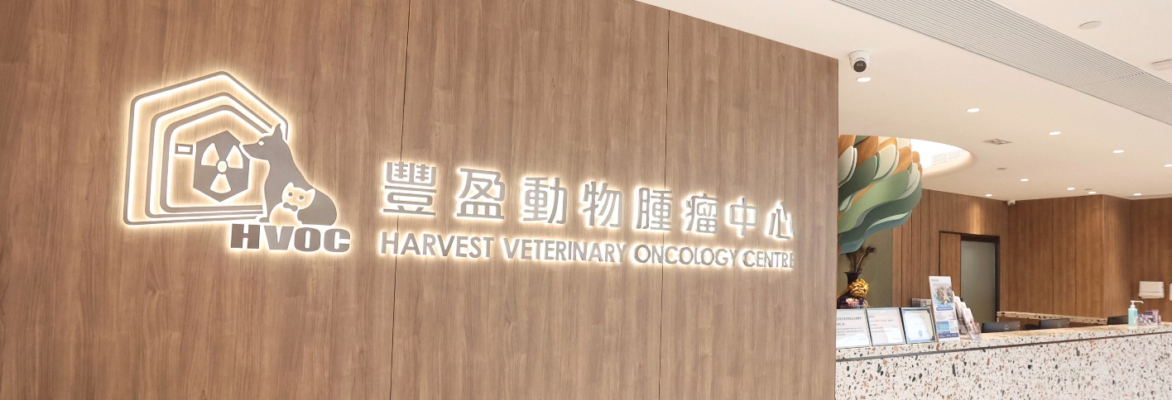

Harvest Veterinary Oncology Centre (HVOC)
Harvest Veterinary Specialty & Emergency Hospital (HVSEH)

Want!

We are an integrated animal hospital offering a full spectrum of clinical services and 24-hour veterinary care. We are looking for the following roles to join our dynamic and collaborative team:
- Medical Oncologist
- Veterinarian Specialist in Neurology
- Full-time Veterinarian (Night Shift)
- Medical Oncologist
Responsibilities
- Perform comprehensive diagnostic evaluations for patients with suspected or confirmed cancer.
- Develop, implement, and manage individualized treatment plans, including chemotherapy, immunotherapy, and targeted therapies.
- Collaborate with surgeons, radiologists, and other veterinary specialists to ensure integrated and comprehensive care.
- Communicate clearly and compassionately with pet owners regarding diagnosis, treatment options, prognosis, and palliative care.
- Maintain accurate and thorough medical records in compliance with veterinary standards.
- Stay current with the latest research and advancements in veterinary oncology and pursue ongoing professional development.

Requirements
- Doctor of Veterinary Medicine (DVM) or equivalent degree from an accredited institution.
- Registered with HKVSB as a Specialist in Oncology (or eligible for registration).
- Proficiency in oncology-specific diagnostic techniques, including cytology, histopathology review, and diagnostic imaging interpretation.
- Strong analytical and problem-solving skills to manage complex oncology cases.
- Excellent communication skills for clear and empathetic discussions with pet owners.
- Ability to work both independently and collaboratively within a multidisciplinary team.

- Veterinarian Specialist in Neurology
Responsibilities
- Perform thorough neurological examinations and assessments to diagnose disorders.
- Utilize advanced diagnostic techniques, including MRI, CT scans, and neurological evaluations.
- Develop and implement effective treatment plans tailored to individual patient needs.
- Collaborate with veterinary technicians, specialists, and pet owners to ensure comprehensive care.
- Conduct neurology surgeries as required to address specific conditions
- Stay current with the latest advancements in veterinary neurology and continue professional development.
- Maintain accurate medical records and documentation in compliance with veterinary standards.

Requirements
- Doctor of Veterinary Medicine (DVM) or equivalent degree from an accredited institution
- Registered with HKVSB Specialist in Veterinary Neurology (or eligible for registration).
- Proficiency in diagnostic imaging and laboratory diagnostics.
- Strong analytical and problem-solving skills to assess complex medical cases.
- Excellent communication skills to convey medical information to pet owners clearly and compassionately.
- Ability to work both independently and as part of a collaborative team.

- Full- Time Veterinarian (Night Shift)

Responsibilities
- Support the ECC team in providing 24/7 emergency services, including urgent medical intervention, critical case management, and continuity of care for hospitalized patients
- Conduct thorough examinations of animals presenting with urgent or critical conditions, diagnose medical conditions, and recommend appropriate treatment plans.
- Respond swiftly and effectively to emergency situations, providing critical care to animals in distress.
- Manage the care of hospitalized animals, ensuring they receive the necessary treatments and monitoring their progress.
- Work closely with other veterinarians, veterinary technicians, and support staff to ensure a cohesive approach to animal care.

Requirements
- Registered with HKVSB.
- Strong analytical and problem-solving skills to assess complex medical cases.
- Excellent communication skills to convey medical information to pet owners clearly and compassionately.
- Ability to work both independently and as part of a collaborative team.
- Previous experience in an emergency veterinary setting or a strong demonstrated interest in emergency medicine is a plus

What makes us different:
Our hospital is equipped with a Linear Accelerator (Linac) for radiotherapy, a Positron Emission Tomography – Computed Tomography (PET-CT) scanner and a 1.5T Magnetic Resonance Imaging (MRI) scanner for medical imaging.
Our team:
At our hospital, we boast a dedicated, experienced, and enthusiastic team of professionals, consisting of veterinary specialists across various specialisms, including Anaesthesia and Analgesia, Oncology, Dentistry and Oral Surgery, Cardiology, and Small Animal Surgery, as well as medical physicists, radiation therapists, nurses, and administrative staff.

Compensation and Perks
We offer competitive salaries, bonuses, flexible work schedules, and a comprehensive benefits package aimed at supporting your overall health and well-being. As a member of our team, you can expect:

- A collaborative and open culture
- A generous salary that reflects the experience you bring to the position
- Assistance with visa applications, including support for your family members, as well as Veterinary Registration in Hong Kong if applicable
- Tailored relocation support with a migration allowance to suit your situation
- Housing allowance
- Group medical insurance
- Continuing education allowance and study leave
- Discounts on pet services and products
- A flexible, ethical roster that acknowledges you have a life beyond work

We offer a generous compensation package based on experience & passion. If these role sounds like a fit for you, please send your resume to hr@hvoc.com.hk with expected salary and available date.

Contact:
Harvest Veterinary Oncology Centre
Shop 1, G/F, Magnet Place, Tower 2, 38-42 Kwai Fung Crescent, Kwai Chung, Hong Kong

Tel: (852) 34263500 Fax: (852) 34210028
Website: https://hvoc.com.hk/en/
Email: hr@hvoc.com.hk

